# Deep Learning based Forecasting and Trading of Credit Derivatives Indices

Rajneesh Kumar Singh

*WorldQuant University*

*singhrajneesh@gmail.com*

# *Abstract*

In this paper we apply Deep Learning architecture to predict the spread of credit default swap (CDS) on the North America Investment Grade index (CDX.NA.IG). The implemented Long-Short Term Memory (LSTM) model is compared with a baseline Support Vector Machine (SVM) model through the root mean squared error. Simulated trading is conducted in the study and the performance compared using Sharpe ratio and maximum loss metrics.

**Keywords:** CDS Spreads, LSTM, Hurst Exponent, SVM

**1. Introduction**

In his debut non-fiction book titled “The Greatest Trade Ever: How One Man Bet against the Markets and Made $20 Billion”, American journalist Gregory Zuckerman narrates behind the scenes story of how John Paulson had pulled off the greatest trade in financial history. “By piling into complex "credit default swaps" against mortgages – in effect, insurance policies that would pay out if homeowners defaulted – his fund made an unthinkable $15bn (£9.8bn) in a year, $4bn of which he took home himself (Stewart, 2010)” and that dwarfed George Soros's billion-dollar currency trade in 1992. The 2015 movie “The Big Short” is based on the same trade.

Credit default swap (CDS) is a credit derivative instrument which is basically like an insurance on the default of the underlying reference entity. The reference entity could be a corporate or any sovereign. These are instruments which protects the buyer in case of default. In return the protection buyer pays a quarterly fee to the protection seller. Many such credit default swaps can be bundled together and form an index swap. For example CDX.NA.IG is one such portfolio of single-name credit default swaps on the 125 most liquid investment grade corporates in North America. European and other regional equivalents also trade actively. Further there are options and tranched products on these macro credit indices (Markit, 2021). For a more detailed understanding of the credit default swaps readers are referred to the Federal Reserve Board’s discussion paper on the same (Bomfim, 2022).

Credit derivative products gained immense notoriety and have largely been blamed for the Great Financial Crisis of 2008-2009. These markets had largely been unregulated before that and is still opaque to many market participants. In an IMF working paper (Elliott, 2009) the authors highlight how credit derivative markets can increase systemic risk due to the inter-connectedness of large financial institutions and how policy makers need to be aware of the “blind-spots” in this market.

Recently the CDS of Russian Federation came into focus as it launched a full-fledged war against Ukraine in early 2022. We can in Figure 1.how the premium on the CDS sky-rocketed as the war progressed and there were fears that the Russian state would not honor the coupon payments on their outstanding bonds. Also notice the volatility around this CDS price.

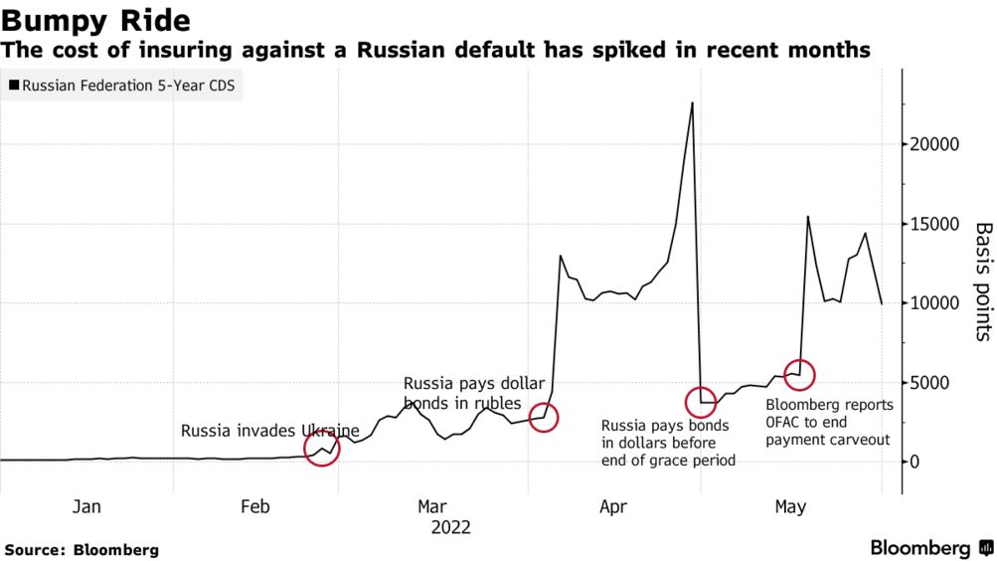

**Figure 1. Russia CDS during Ukraine War in 2022**

To implement a hedging and/or a trading strategy, the accurate forecasting of CDS spreads becomes important. This is useful not only for investors looking to gain from the price moves, it is important for risk managers looking to hedge counterpart risk and for policy makers framing a policy response to systemic risk after global markets.

We focus our forecasting task not at individual corporate or any country CDS level. Our focus is going to be credit indices which are like barometer of overall credit risk of whole economy just as the VIX index represents volatility measure for macro equity index, SPX. While other asset classes like equity, bond and foreign exchange get lot of attention with regards to new forecasting techniques using machine learning and deep learning, work on credit derivative asset class looks minimal in comparison. We look to bridge this gap with our study.

**2. Related Work**

While a lot of studies has been done on the determinants of CDS spreads, the literature is sparse on price forecasting. (Avino, 2014) did an analysis of two linear forecasting models, ordinary least squares and an AR(1) model as well as a Markov regime-switching approach and found some evidence of statistical predictability. His instrument of choice was the iTraxx CDS index and the data covered the 2008 financial crisis. iTraxx index is a pool of CDS on 125 investment grade corporates in Europe. They found the Markov switching model underperforming the linear models under study.

With the advent of machine learning models researchers have begun to apply them to the credit derivative markets. Support Vector Machines were applied by (Gündüz, 2011) to single-name CDS prices and were found to outperform the Merton model. This study is extended by (Zhang, 2018) where they predict the returns rather than the CDS prices and also adds a few features.

In an IMF working paper by (Hu, 2019) ensemble machine learning methods were applied on firm level accounting-based, market-based and macroeconomic variables to generate CDS spreads which can be helpful for arriving at CDS spreads for companies who don’t have an active CDS market. The ensemble methods used were Bagging, Gradient Boosting and Random Forest.

Are CDS spreads predictable? And does efficient market hypothesis apply to the credit derivatives markets? With this dual goals (Vukovic, 2022) investigated the daily CDS spreads for 513 leading US companies over the time-period 2009-2020. The study splits the period as pre and post Covid-19 to check if there were changes in the market efficiency. The forecasting tools they used were Support Vector Machines, Group Method of Data Handling, Long Short-Term Memory and Markov switching auto regression. The results show the prediction results are not very different before and during Covid-19. But they did find that the market became less efficient during the pandemic. The GMDH and MSA models outperformed SVM and LSTM.

As we can see the latest machine learning and deep learning models for time series forecasting of credit default swaps spreads has been able to provide better results compared to traditional methods. This is consistent with the findings in other asset classes where researchers have been reporting superior results. This also means that efficient market hypothesis may not hold for CDS price movements and the moves may not be mere random walks. Fractal Market Hypothesis (FMH) could be an alternative for CDS prices especially during periods of market turbulence.

FMH studies have been conducted on various markets using a variety of methods to establish the fractal properties of the time series. Using the CDS spreads of Turkey, Russia, South Africa and Brazil, (Günay, 2016) examine the long-memory dependency in its volatility. Hurst Exponent Analysis was used by (Balkan, 2022) on the CDS spreads for 34 OECD countries between March 2003 and February 2020. Using rescaled range analysis with four different frequencies the researchers were able to show persistency in all CDS spreads and therefore upholding the FMH.

The pricing of CDS under Generalized Mixed Fractional Brownian motion has been considered by (He, 2014) and they provide a closed-form analytical expression for the CDS under risk-neutral assumption. The long memory in highly volatile time series of cryptocurrencies is examined using Hurst exponents of log returns in (Sheraz, 2022) as this nascent market has demonstrated sufficient divergence from normal distribution assumption.

**3. Methodology**

Our literature survey has provided evidence of long-term memory in CDS prices from two independent approaches that researchers have taken: fractal markets and using deep learning model like LSTM. This motivates us to combine the two approaches and see if better forecasting results can be achieved.

Broadly speaking we are curious to see if a data driven model like LSTM performs better than traditional model driven SVM and if Hurst Exponent Analysis on CDS spreads helps with forecasting accuracy. To our knowledge there are no study using Hurst Exponent and machine learning/deep learning at the same time. With this dual objectives in mind we would like to test a couple of hypotheses as below.

**Hypothesis I:** LSTM model performs better than traditional SVM in predicting CDS spreads.

**Hypothesis II:** The forecast accuracy improves when we incorporate a rolling Hurst Exponent series as an additional input feature.

This paper is organized as follows: in the next section, we review our dataset and present a statistical summary of the CDX.NA.IG CDS spreads; we describe our methods: LSTM and the baseline SVM model; next we will present our forecasting results with various error estimates and demonstrate the performance of each model; and lastly we will provide the summary and concluding remarks of our study.

**3.1. Data**

CDX.NA.IG index consists of 125 most liquidly traded CDSs in North America. We source the 5Y spread on this index for the last 10 years using Bloomberg terminal. Our data covers the period from January 2012 to December 2022 and 4018 observations in total. We will do a detailed study of the data patterns to check the suitability of using our proposed LSTM and SVM algorithms. Our exploratory data analysis will focus on identifying the time series properties of the data set. In particular statistical analysis will be done for identifying presence/absence of trends, cycles, seasonality and clustering in the data. We will test the time series of stationarity as well.

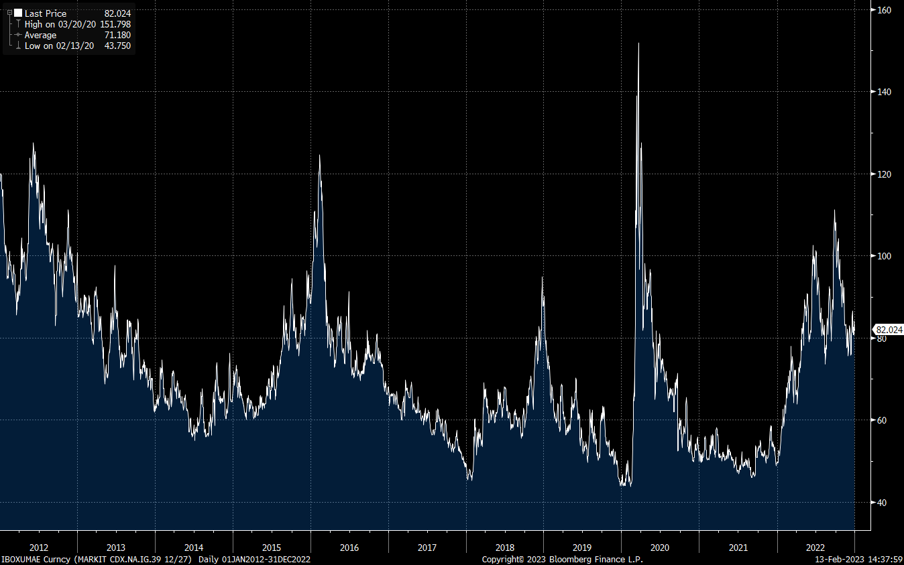

**Figure 2. CDX.NA.IG Historical Spread**

We find higher volatility in CDX.NA.IG returns compared to the S&P 500, while volatile market periods are notable in both, as shown in Figure 3. At the same time Figure 4 do tend to show that the returns deviate from normal distribution.

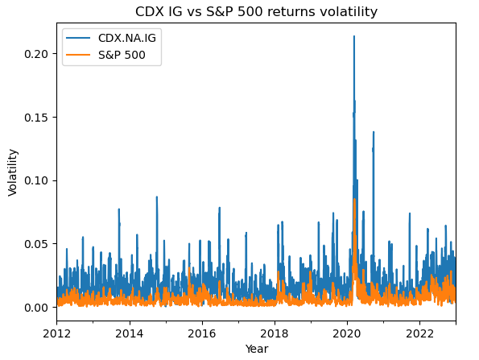

**Figure 3. CDX.NA.IG vs S&P Index Returns Volatility**

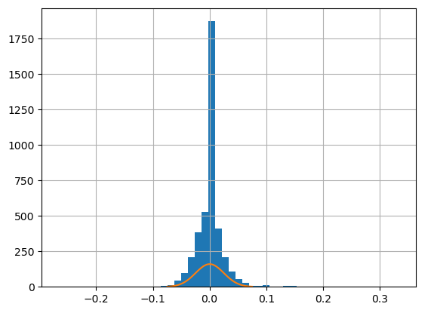

**Figure 4. CDX.NA.IG Returns Distribution**

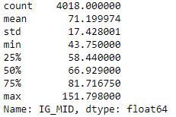

**Table 1. Summary statistics for the historical CDX.NA.IG spreads**

We perform an Augmented Dickey-Fuller (ADF) test for stationarity in spread and returns series. As seen in Figure 5 our p-value comes less than 0.05 which means we reject the null hypothesis that the data does not have a unit root and is therefore stationary.

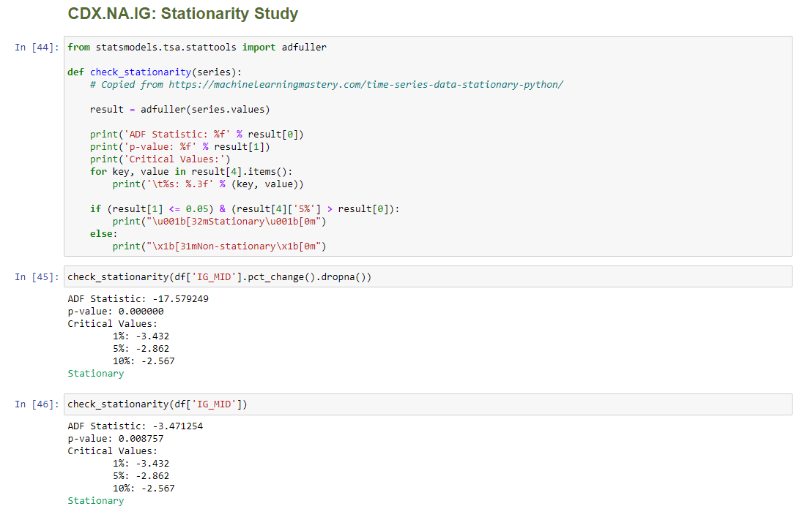

**Figure 5. Code snippet for testing Stationarity of CDX.NA.IG spreds**

Since our ADF test shows that the returns of the time series is stationarity we proceed with the next step to check the autocorrelation. This is correlation with a lagged version of the time series. The Autocorrelation Function (ACF) plot in Figure 6 can help find the order of autocorrelation in the time series.

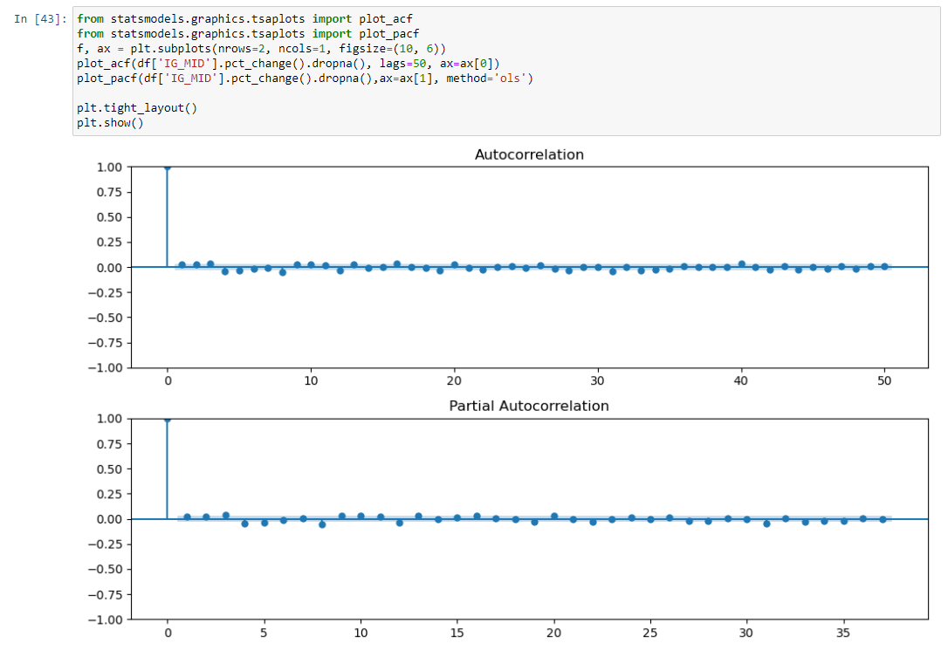

**Figure 6. Code Snippet for Testing Autocorrelation of CDX.NA.IG Returns**

We do not find strong evidence of autocorrelation of the CDX.NA.IG spread returns from the ACF and PACF plots in Figure 6 but at the same time a visual inspection of the spread changes time series do show clustering of returns. As noted from Figure 7 we can see large spread changes are clustered around few macroeconomic events of which the COVID-19 period stands out.

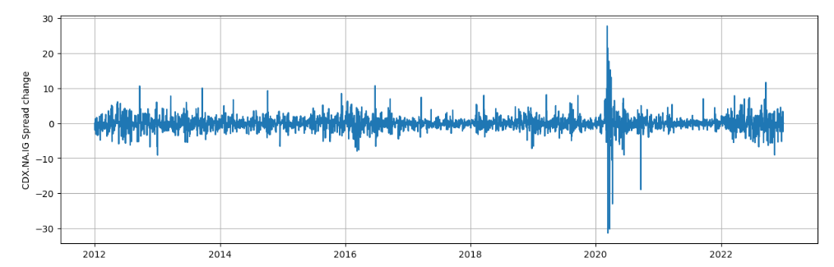

**Figure 7. Clustering of CDX.NA.IG Returns**

After doing a sub-period study for seasonality, we find little evidence of it as seen in the Figure 8.

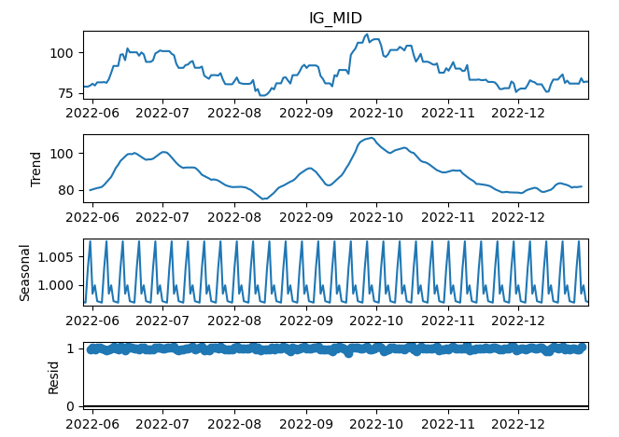

**Figure 8. Seasonality of CDX.NA.IG Returns**

**3.2. Models and Training**

We apply a deep learning based architecture, LSTM model, to the prediction of CDS spreads of the CDX.NA.IG index and investigate model performance versus a benchmark SVM model. We will use Mean Squared Error (MSE) as the primary performance metric and will also report Mean Absolute Error (MAE) as well as Mean Absolute Percentage Error (MAPE) as additional metrics. We use MSE as loss function because we strive to minimize the difference between predicted return and true return.

We will also focus attention on our hyper parameter optimization to arrive at the optimal values for the LSTM model parameters: number of epochs, learning rate, decay rate, batch size and look-back window. Adam is our choice of optimizer in the LSTM algorithm.

In order to test our two hypotheses we plan to conduct two set of prediction tasks:

1. LSTM and SVM forecasting with just the CDX.NA.IG time series data input.
2. LSTM and SVM forecasting with a time series of rolling Hurst Exponent values as an additional input feature.

The pseudo code for calculation of Hurst Exponent time series is presented in the appendix. A rolling time series of the Hurt Exponent will be appended to the CDX.NA.IG time series and will serve as additional input feature.

**3.2.1. Support Vector Machines:** SVM is a class of supervised machine learning and is often used for regression analysis. The basic idea behind SVM is to find a hyperplane that maximizes the distance between classes. It is very useful for classification tasks.

MORE MODEL DETAILS TO FOLLOW

**3.2.1. Long Short-Term Memory:** LSTM is a type of Recurrent Neural Network where dependency on the past data can be modelled. Unlike the usual feedforward neural network, LSTM models have a feedback connection which can learn time dependent relationship in the data and are therefore more suitable for time-series data modelling. Another advantage of these class of models is its ability to overcome the vanishing gradient problems seen in traditional neural networks. Currently LSTM dominates forecasting problems in most of the asset classes and we intend to study its utility to credit derivatives through this study.

Figure 9 details a single unit of a LSTM architecture. In the context of modelling LSTM for time-series data each timestamp is a single LSTM unit which takes the input at time *t* and process the data and passes on the output to the next LSTM unit. The forget gate controls what information doesn’t get passed to the next unit and the input gate stores the information deemed to be important.

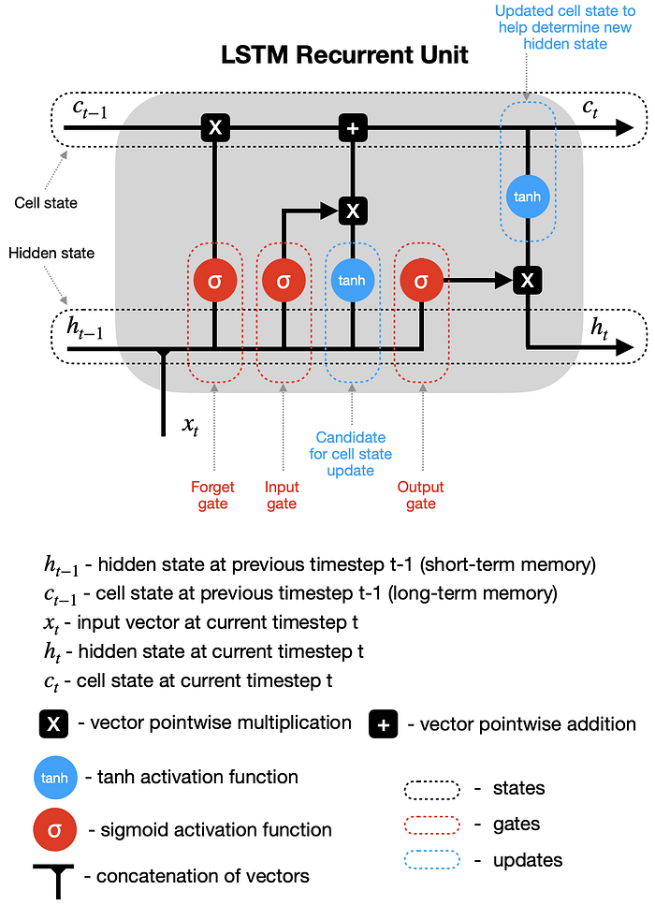

**Figure 9. A single LSTM recurrent unit** (Dobilas, 2022)

MORE MODEL DETAILS TO FOLLOW

**4. Results**

RESULTS TO FOLLOW

**5. Discussion**

DISCUSSION TO FOLLOW

**6. Conclusion**

CONCLUSION TO FOLLOW



# Appendix

**A. GitHub Repository**

An online repository for the current project is publicly available at the below GitHub address. The plan is to provide all the files and working codes to the online repository. Currently four python notebooks are posted to the repository together with input data for replication of reported results.

<https://github.com/rks972633/MScFE_Capstone>

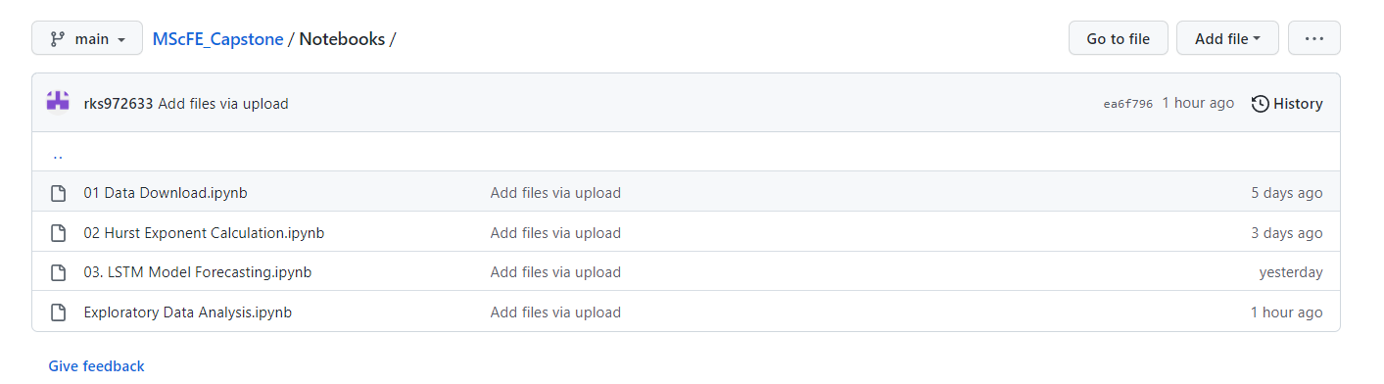

**B. Pseudocode**

Below algorithm for calculation of Hurst Exponent is motivated from (Sheraz, 2022).

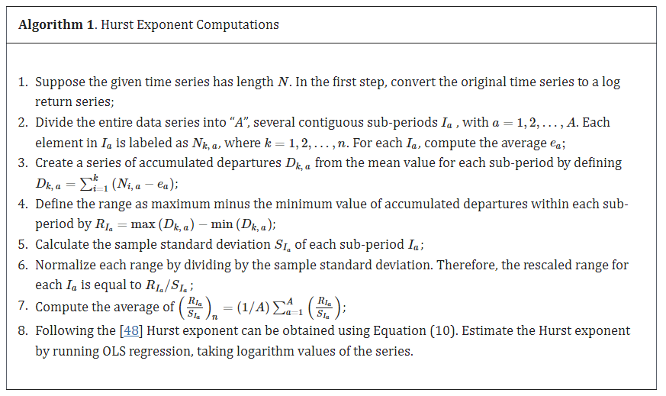

# Acknowledgments

I would like to thank Dr. Tiberiu Stoica at WorldQuant University for the guidance provided throughout the conduct of this study.

**References**

1. D. Avino and O. Nneji, “Are CDS spreads predictable? An analysis of linear and non-linear forecasting models”, International Review of Financial Analysis, vol. 34, **(2014)**, pp. 262-274.
2. E. Balkan and U. Uyar, “The Fractal Structure of CDS Spreads: Evidence from the OECD Countries”, Romanian Journal of Economic Forecasting, vol. 25.1, **(2022)**, pp. 106.
3. Bomfim, A. N. **(2022)**. Credit Default Swaps. Finance and Economics Discussion Series 2022-23. Retrieved from https://doi.org/10.17016/FEDS.2022.023.
4. Elliott, M. J. **(2009)**. Credit derivatives: systemic risks and policy options? International Monetary Fund.
5. Günay, S. a. **(2016)**. Long-memory in volatilities of cds spreads: evidences from the emerging markets. ournal for Economic Forecasting 1, 122-137.
6. Gündüz, Y. a.-H. **(2011)**. Predicting credit default swap prices with financial and pure data-driven approaches. Quantitative Finance 11.12, 1709-1727.
7. Gupta, R. G. **(2020)**. Retrieved from https://streetfins.com/analyzing-bill-ackmans-2-6-billion-cds-trade/.
8. He, X. a. **(2014)**. The pricing of credit default swaps under a generalized mixed fractional Brownian motion. Physica A: Statistical Mechanics and its Applications 404, 26-33.
9. Hu, N. J.-C. **(2019)**. Completing the Market: Generating Shadow CDS Spreads by Machine Learning. International Monetary Fund.
10. Markit, I. **(2021)**. Retrieved from https://cdn.ihsmarkit.com/www/pdf/1221/CDS-Indices-Primer---2021.pdf.
11. Sheraz, M. S. **(2022)**. Volatility Dynamics of Non-Linear Volatile Time Series and Analysis of Information Flow: Evidence from Cryptocurrency Data. Entropy 24.10, 1410.
12. Stewart, H. **(2010, March 07)**. Retrieved from https://www.theguardian.com/books/2010/mar/07/the-greatest-trade-ever-by-gregory-zuckerman-review-heather-stewart.
13. Vukovic, D. B. **(2022)**. Are CDS spreads predictable during the Covid-19 pandemic? Forecasting based on SVM, GMDH, LSTM and Markov switching autoregression. Expert systems with applications.
14. Zhang, T. Y. **(2018)**. Predicting Credit Default Swap (CDS) Returns with Machine Learning. Available at SSRN 3152143.

**Authors**



**Rajneesh Kumar Singh,** is a current student at WorldQuant University pursuing his Master of Science in Financial Engineering. He has been a financial markets professional for over 15 years and has mostly worked in the field of Credit Derivatives in various roles. Currently he works as a Credit Quantitative Research in a London based credit hedge fund.